# How to get SOAP service method and parameter from WSDL address

## Introduction

When access to WCF service, user can download the service description xml WSDL file from service address. Sometimes, user need use SOAP way to invoke service method. However user can’t post WSDL format to service address. They have to convert the WSDL format xml to SOAP format. This sample demonstrates how to get SOAP service method and parameter from WSDL address.

## Sample prerequisites

* Visual studio 2015

## Running the sample

* Open the solution file in archive
* Download the target WSDL file from WCF service address, for example, if your service address is <http://localhost:6742/Service1.svc> then you can download the WSDL file with from <http://localhost:6742/Service1.svc?singleWsdl>
* Change the WSDL file path in Program.cs line 18

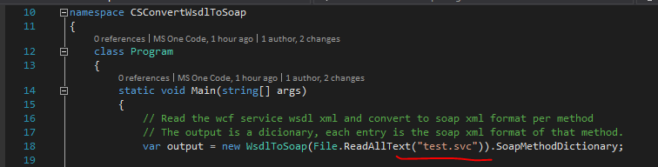

* Then run or debug the project, you will get the dictionary output which contains all SOAP format method definition

## Using the code

When customer need to invoke SOAP style service on WCF service, they can make use of the sample code to generate SOAP formation content to do invocation.

The sample implements **WsdlToSoap** utility to do the tedious job to convert WSDL to SOAP. You can make use of it as you like.

Below is the code snippets about how to do SOAP invocation on WCF service making using of the convert class.

[code snippets]

## More information

* WSDL definition: <https://www.w3.org/TR/wsdl>
* SOAP definition: <https://en.wikipedia.org/wiki/SOAP>